**Microeconomics and business**

## What is Scarcity?

The world is a finite place and people face the problem of scarcity.  Scarcity is the condition in which human wants are forever greater than the available supply of time, goods, and resources.  You cannot satisfy all desires due to scarcity. Think for a minute of some of the things that you want. Maybe it’s a bigger home, nicer car, cleaner air…  Unfortunately, nature cannot fulfill every desire. There are limits to the economy’s ability to satisfy all wants.

Scarcity is around for both rich and poor.  Perhaps you think that if you had more money you would not have a scarcity problem, but even the rich desire faster planes and larger yachts.  Everyone is always seeking more. Even the government. The government never has enough money to spend on the poor, education, infrastructure, Social Security and all sorts of programs that need funding.

Scarcity is a fact of life.  In some countries in South America, Africa, and Asia, it can be life threatening, but in other countries in North America, Western Europe it is not.  But scarcity exists as I’ve explained because individuals and countries never have as much as they would like to have. Scarcity and Choice are basic economic problems faced by every society.

## Entrepreneurship

Entrepreneurship is a special type of labor that we’ll explain separately.  **It is the creative ability of individuals to seek profits by taking risks and combining resources to produce innovative products.** *Entrepreneurship organizes the three basic resource categories to produce goods and services.* Is entrepreneurship scarce? Well, yes, it is a scarce resource because few people are willing or able to innovate and take risks that have a greater chance of failure. **An entrepreneur is a motivated person who seeks profits by undertaking risky activities.** Some examples of these risky activities can be starting a new business, creating new products, or inventing new innovative ways of accomplishing tasks. But *Entrepreneurship is what creates a growing economy.*

Levi Strauss is an example of an entrepreneur. In 1853, he sailed from New York to California to join the California Gold Rush. He was there to dig for gold, but he wanted to sell cloth. By the time he arrived in San Francisco, California, he had sold most of his cloth to the people on the ship. All he had left was a roll of canvas for covered wagons and tents. What good was that going to do? Well, on the dock, he met a miner that wanted sturdy pants that could last while he was digging for gold, so, Strauss made him a pair of pants from the canvas. Later, a customer gave Strauss the idea of using copper rivets to strengthen the seams. Levi Strauss knew it was a great idea, so he hired workers and built factories and became one of the largest pant makers in the world. He took a risk, organized his resources and production, and introduced a product. The Levi Strauss company earned profits, and Strauss became a successful businessman.

## Five Step Decision Model

#### Other disciplines have procedures for solving problems. For example, you might have used the scientific method in a chemistry class. So, how do economists solve problems? They have a method too. They create a model. How is the model created? Economists use the Five Step Decision Model of the economic method.

**First identify the problem.** Sounds obvious, right? You have to identify the issue. An example issue would be why did U.S. motorists decrease gasoline consumption in a given year, from say 400 million gallons per day in May to 300 million gallons per day in December. You identify the issue and problem you’re trying to solve.

**The second step towards finding an explanation is to develop a model.** A model is a simplified description of reality used to understand and predict the relationship between variables. Some people interchange the words model and theory. The purpose of a model is to make events understandable. You want it simple, absent of complexities. Say, you’re trying to find the best route between Omaha and Chicago. You need a highway map, but the map doesn’t need to include locations of extra things like potholes, trees, stoplights. That’s too much detail. Too many complexities. In order for a model to be useful, it requires simplified assumptions.

**Third, collect Data.** Say you’re doing a study on gasoline consumption. You’ll want to make a list of variables that could affect consumption. For example, this data could include things such as consumer income, gasoline price, fuel economy. You’ll want to collect data on these critical variables.

**Fourth, test your theory.** Say you think that when gas price rises, consumption falls. You’ll want to test this theory using the data you’ve collected. If A happens, then B follows, while other variables are held constant. If the evidence is consistent with your statement, then your theory may be valid.  If the evidence is inconsistent with the theory that A causes B, then you reject your theory.

**Finally, you formulate a conclusion.** Basically, is your model or theory valid. Does A cause B? Is the data consistent with your theory?

## Positive and Normative Economics

Sometimes economists disagree, and that’s okay.  Typically, it can be explained by the difference between positive and normative economics.

**Positive economics deals with facts** asking “what is” or verifiable questions.  *These are testable statements that use if-then.* **Positive economics deals with analysis limited to statements that are verifiable.**  We don’t care if the statement is true, only that it can be tested.

Suppose we have data that shows the unemployment rate is close to nine percent, the teenage unemployment rate never reaches 80%.  So, the unemployment rate in 2009 was 9.3 percent and the rate for teenagers was 24.3 percent, which is considerably less than 80%.  With those facts, we could conclude the statement, the unemployment rate is close to nine percent and the teenage unemployment rate never reaches 80%, is true. This is a positive economic statement because we can test it.

**Normative economics uses subjective instead of objective statements.**  It tries to determine “what should be”. *It’s an analysis based on value judgement or opinions and uses words such as good, bad, ought to, and should.*  People wearing different color glasses see the same facts differently. Each of us have subjective preferences that we apply to particular subjects. An example would be an animal rights activist that says no one should purchase a fur coat.  Or a congressman that says “We ought to ensure that every teenager who wants a job has one.”  Notice the word choice: Should, ought to. These are common words used in judgement or opinion statements.

## Direct Relationship

So, we’ve discussed some basic terms and the economic way of thinking, but how do we show relationships between variables?  One way is through graphs.

Note the graph, it shows a positive relationship between Expenditures and Income. As Income increases, so do expenditures. This is a direct relationship. It is a positive association between two variables.  When one variable increases, the other variable increases and vice versa, when one decreases, the other decreases.

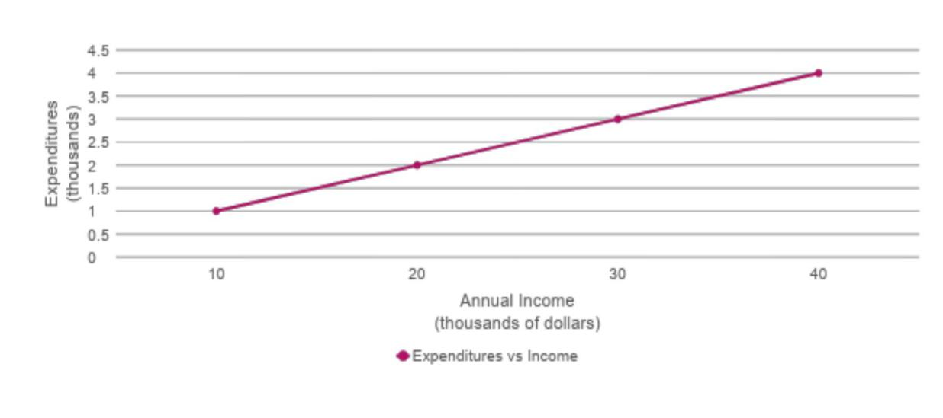

Here is another example of a direct relationship.  This chart and graph show the relationship between Personal computer expenditures and annual income.  As the annual income increases on the X-axis, the expenditure increases on the Y-axis.  This is a straight line graph, so the slope is constant between points.  The slope between points B and C of 1/10 is the same at the slope between points A and D, 3/30, which simplifies to 1/10.

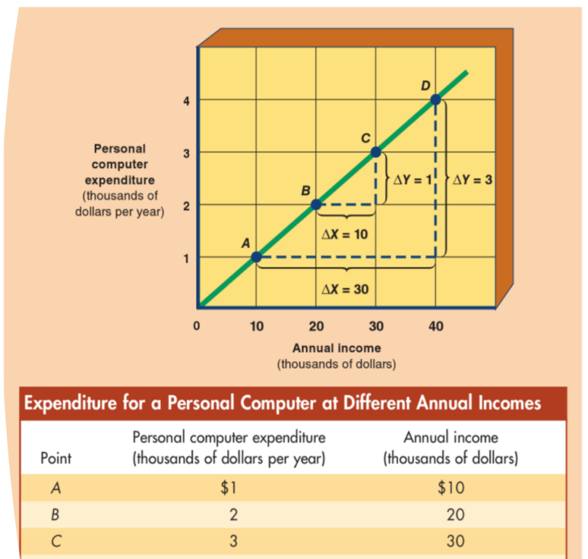

## Inverse Relationships

This graph depicts an inverse relationship between the variables of price and quantity purchased.  This is a negative association between two variables. When one variable increases, the other decreases, and when one variable decreases the other variable increases.

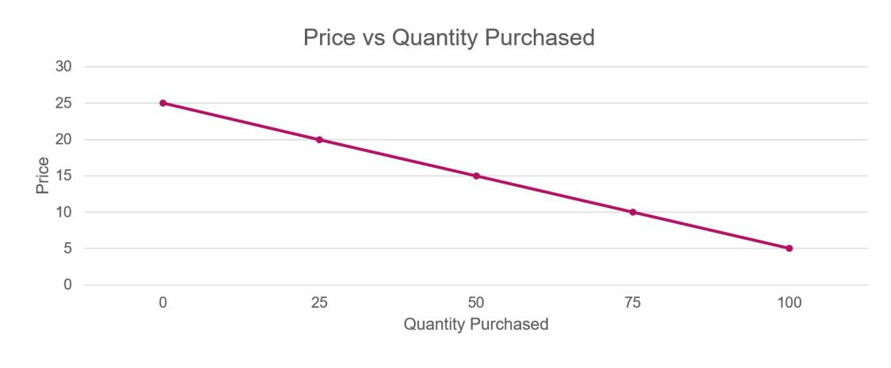

Here is another example of an inverse relationship.  This chart and graph show the relationship between quantity of compact discs purchased as price changes.  As the price of the compact disc decreases, the quantity purchases increases. This is a straight line graph, so the slope is constant between points.  The slope between points C and D is -5/25 of -1/5.

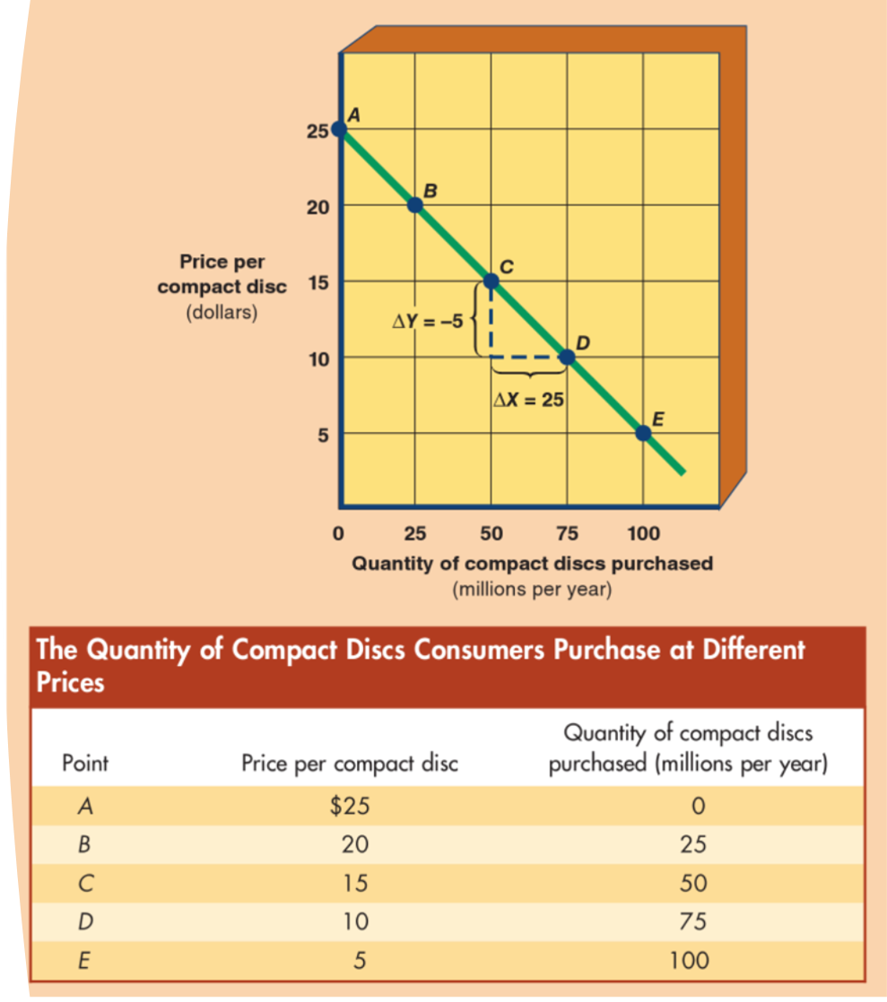

## Slope of a Line

Slope. What is it and what is it good for?  When you plot a graph, you get a visual expression of the relation between two variables.  But how do we find out how much one variable changes as the other variable changes. We use the slope.  The Slope is the ratio of the change in the variable on the vertical axis (the rise or fall) to the change in the variable on the horizontal axis (the run).  If the slope is positive, we call that upward sloping. On the contrary, if the slope is negative, that is downward sloping. If the slope is 0, and the line is flat (horizontal), then the variables are said to have an independent relationship. This can also happen if the line is vertical.  There is a zero association between two variables. When one variable changes, the other remains unchanged.

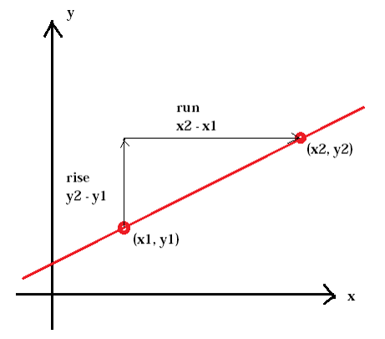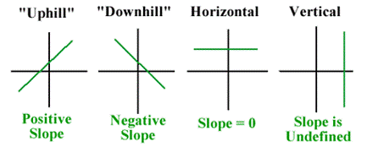

## Opportunity Cost & Marginal Analysis

The three fundamental economic questions cannot be answered without sacrifice or cost.  But what is cost? You might think it’s the $10 you spent on a movie ticket, but economists define it differently.  Because of scarcity, people make choices, each choice incurs a cost or a sacrifice.

The money you spend on a pretzel, cannot be used to buy a hamburger.  So, the true cost of a decision is the opportunity cost of a choice, not the purchase price.  **Opportunity cost is the best alternative sacrificed for a chosen alternative.** You have one hour.  You can either bake cookies or watch a television show.  You choose to watch television, what is your opportunity costs.  The opportunity cost is the chocolate chips cookies that you could be eating right now, if you had chosen to bake them.

There is a link between scarcity, choice, and opportunity cost.  *Scarcity means there is not enough resources to produce all the goods and services to satisfy all human wants.* *Therefore, society has to make a choice. Each choice or decision made has a sacrifice. A sacrifice in terms of the alternative was not chosen.*

## Marginal Analysis

Marginal analysis is at the heart of many decision-making techniques. **It examines the effects of additions to or subtractions from a current situation.** *A rational decision maker decides on an option if the marginal benefit exceeds the marginal cost.* For example, there are many ways to spend time. You have one hour. What do you do? Do you sleep, do house chores, or study economics? You use marginal analysis to make your decision. If you decide that understanding economics has a greater benefit than sleep, then you’ll choose to study economics, and I thank you for that.

## Economic Growth

The Production capacity of an economy is not permanently fixed. If the resource base increases or technology advances, then the economy will experience economic growth, causing the production possibilities curve to shift outward. **Economic growth is the ability of an economy to produce greater levels of output, represented by an outward shift of its production possibilities curve.** There are **two sources of economic growth: change in resources or technological change.** An increase in resources such as more factories, more natural resources, and even a baby boom will shift the production possibilities curve outward. With additional labor or factories, the capacity to produce will increase. With additional resources, the production possibilities curve will move outward, as additional products can be produced. Technological change can also shift the curve outward by producing more from the same resources. Some sources of technological change are invention or innovation. Computer chips, satellites, internet, entrepreneur creations are all technological changes.

**Law of Demand**

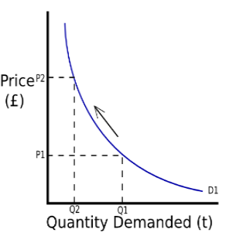

The Law of Demand is the principle that there is an inverse relationship between the price of a good and the quantity buyers are willing to purchase in a defined period, ceteris paribus.  Ceteris paribus, there’s that term from module 1. Remember it means everything else held equal. Simply, it means at a sale, consumers will buy more when the price of merchandise is cut.  The graph shows a demand curve. You can see that as the price increases the quantity demanded decreases and as the price decreases, the quantity demanded increases. Demand is a curve or schedule showing the various quantities of product consumers are willing to purchase at possible prices during a specified period of time, ceteris paribus.

Note this demand schedule.  This shows how many small sodas are purchased at possible prices.  As the price of soda declines, the quantity demanded increases. As the price of the soda increases, the quantity demanded decreases. This inverse relationship between price and quantity demanded conforms to the law of demand:  the principle that there is an inverse relationship between the price of a good and the quantity buyers are willing to purchase.

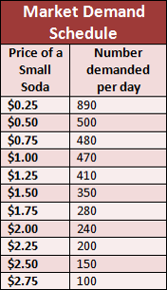

## Law of supply

We’ve talked about the Law of Demand, let’s shift to the Law of Supply. **The law of supply states that there is a direct relationship between the price of a good and the quantity sellers are willing to offer for sale in a defined time period, ceteris paribus.** *Being that this is a direct relationship, as price increases, the quantity supplied by the seller increases.* Supply is a curve or schedule showing the various quantities of a product sellers are willing to produce and offer for sale at possible prices during a specified period of time, ceteris paribus.

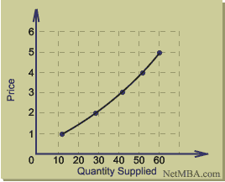

Look at this graph.  At a price of 1, the seller supplies 10.  At a price of 5, the seller provides 60. So, why are sellers willing to sell more at a higher price?  Because it would be more profitable! Think about Black Friday. When a 50 inch television is available for $100, the quantity available is limited.  The seller does not want to offer a significant amount of product at a lower price. At a higher price it will be more profitable for sellers to incur the higher opportunity cost associated with producing and supplying a larger quantity.  Remember, to produce one good, you sacrifice producing another good. That’s the definition of opportunity cost.

## Market Supply

The Market Supply curve is similar to the market demand curve. To go from an individual supply curve to a market supply curve, we sum or total the individual supply schedules.  In this example of Firm A and Firm B, we sum their individual supply curves to form one market supply curve. How do we do this? For example at a price of 15, Firm A supplies a quantity of 4.  At a price of 15, Firm B supplies a quantity of 2. So if we combine the supply, in the market supply curve at a price of 15, there will be a total of 6 quantities supplied because 4 from Firm A and 2 from Firm B equals a supply of 6 in the market.

We simply sum up the quantities supplied at various prices in the market.  So, again, at a price of $15, Firm A supplies 4 and Firm B supplies 2. The market supply curve has 6 (4+2=6) quantity supplied at $15.

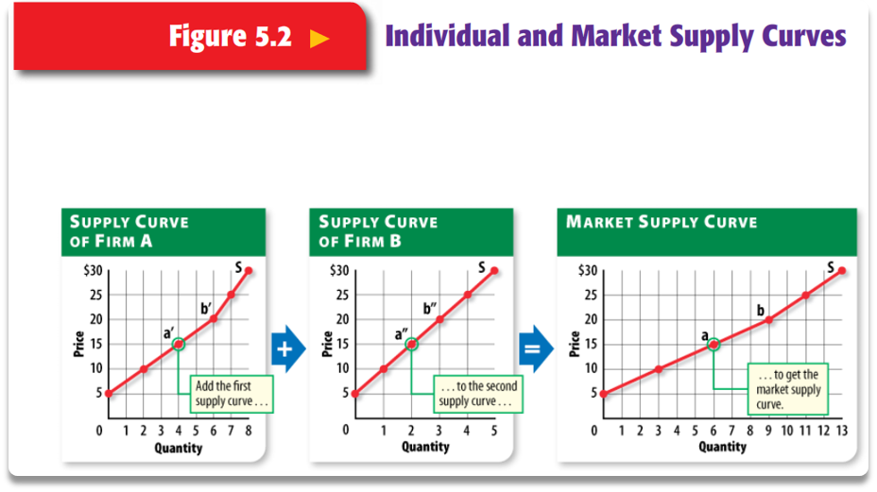

The Change in quantity supplied is a movement along a stationary supply curve, ceteris paribus.  A change in supply is an increase or decrease in the quantity supplied at each possible price. An increase in supply is a rightward shift in the entire supply curve.  A decrease in supply is a leftward shift in the entire supply curve. Under the law of supply, an increase in price will cause an increase in quantity supplied. Changes in non price determinants can produce on a shift in the supply curve and not in a movement along the supply curve.  A non price determinant causes a shift in the supply curve , right of left, that is due to the change in price of the goods.

## Non-Price Determinants of Supply

We will discuss 5 non price determinants of supply.  They include

Number of Sellers

Technology

Resource Prices, Taxes, and Subsidies

Expectations of Producers

Prices of Other Goods the Firm Could Produce

**Number of sellers** can decrease or increase in the market for many reasons. Weather may ruin a tomato crop, forcing growers out of business. Or maybe there are eases in trade restrictions, causing an increase in sellers. As sellers enter and exit the market, supply increases or decreases.

**Technology** allows efficiency to manufacture more products. It is possible to offer more products for sale at each price, shifting the supply curve to the right.

**Resource prices** affect supply. As the price for resources increases, this adds to cost. As production price increases, quantity supplied decreases and vice versa, as production price decreases, quantity supplied increases. Taxes have the same effect as increase price of resources, quantity supplied decreases. Subsidies have the same effect and lower resource prices, quantity supplied increases, and the curve shifts to the right.

**Expectations of producers**, suppose there is a conflict in the Middle East. Because Suppliers know that oil prices will rise dramatically, they will hold off on supply so they can sell more when prices increase and make a greater profit.

**Price of other goods and services**, a rise in the price of one product relative to the prices of other products signals to suppliers that switching production to the product with the higher relative price yields a higher profit. For example, if the price of a brand name drug increases, manufacturers will supply less of generic drugs. The common thread here is altering quantity supplied to increase profits.

**Supply and demand is the quantity of products that producers want to sell at different prices. Also to take into consideration in the key factors of this is being able to understand the quantity customers want to buy, To establish a 'perfect' supply and demand is called an equilibrium and this will mean the quantity demanded matches how much the producer wants to sell at the same price that the customers are willing to pay. On a graph, it can be useful to obtain that if the supply demanded exceeds quantity demanded, then this is called a 'surplus', found above the equilibrium line, which is essentially a perfect match of supply and demand. A surplus means there are too many products supplied, therefore sellers can't sell these as there is no demand for them. However, the opposite of this is a 'shortage', which is when demand is higher than the supply a producer is willing to sell. This could be due to certain factors, including it is not at the price the seller is wanting to sell it at. For example, in a sale, a seller is less likely to sell many discounted items, as this is less profitable for them. A shortage on a graph is found below the equilibrium line.**

## Changes in Market Equilibrium

Now that you understand Supply and Demand, you have a clearer view of the world. Last module we learned a little bit about pricing. Most people think that prices are set by sellers adding percentage to their costs. So, if the seller’s costs rise, they just raise their prices according to that percentage. But now, we know that’s not necessarily true in a free market. We know that the market equilibrium decides the price. We will study three topics that can change Market Equilibrium.

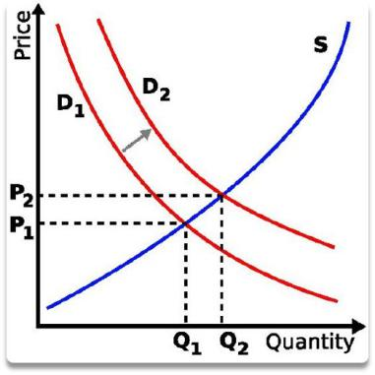

**First, Change in Demand.** In this picture, the Change in demand has shifted to the right. Notice how the equilibrium price, the intersection of the supply and demand, curves changes as well.  The Increase in demand has caused an increase in Equilibrium Quantity (Q2) and Equilibrium price, where Demand curve D2 and the Supply curve intersect.  Note from the previous module, that this is a shift in the demand curve, so there must be a non price determinant causing this shift. Let’s think about this logically, with an increase in demand of a product and the supply staying the same, there will be a shortage.  Since the product is in greater demand and there is not enough quantity to meet the demand, then seller can increase the price to bring the market back into equilibrium.

Now let’s reverse this and have demand remain constant.  This graph shows a change in quantity supplied. As the Supply curves shifts right, the equilibrium price decreases (P1 to P2) and the equilibrium quantity increases (Q1 to Q2).  Now, demand is staying the same, but the supply is increasing. Now there is a surplus in the market. So, because there is excess product in the market, the seller will need to decrease the price in order for the product to sell and bring the market back into equilibrium.

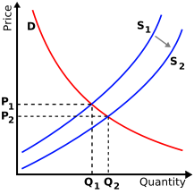

This chart shows the effect of shifts in demand or supply on Market equilibrium.  It is a chart representation of what we just explained on the graph.

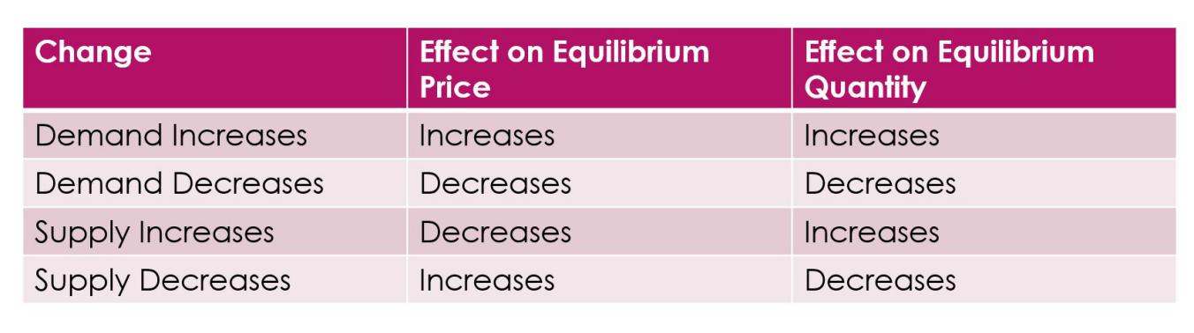

Showing the change of Supply and Demand curves over time can allow us to formulate a trend line.  We can see how the observed equilibrium price changes over time due to non-price determinants.

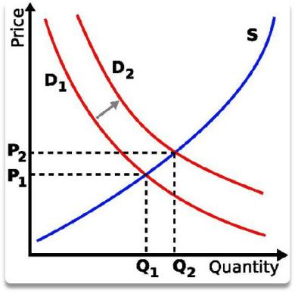

**Price Elasticity of Demand**

**The Price Elasticity of Demand is the ratio of the percentage change in the quantity demanded of a product to a percentage change in price.** Previously, we studied the demand curve, and our focus was on the law of demand, mainly the inverse relationship between price and quantity demanded. We will now measure the relative size of changes in price and the quantity demanded. For example, what percentage change does the quantity demanded rise, if the price falls 20 percent.

**Economists use the price elasticity of demand formula to measure the degree of consumer responsiveness or how sensitive consumers are to a change in price.** Let’s think of this in terms of a rubberband. The quantity demanded is the rubber band. The Price Elasticity of demand measures how “stretchy” the rubber band is when the price changes.

## Example of Price Elasticity

Ed is called the Elasticity coefficient and is used to measure the degree of elasticity. **The elasticity formula is the percentage change in the quantity demanded divided by the percentage change in price.** When computing the Elasticity coefficient, you’ll want to use the Midpoints formula. The midpoints formula can be expressed as the change in quantity (Q2-Q2) divided by sum of the quantities (Q1+Q2) divided by the change in price (P2-P1) divided by the sum of the prices (P1+P2).

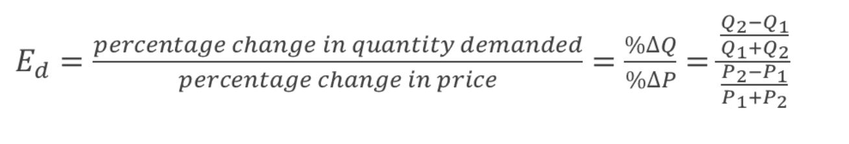

So, let’s work through an example. Suppose with concert tickets priced at $35, you can sell 10,000 tickets. If the price lowers to $25, then 20,000 tickets are sold. What is the price elasticity of demand? Using the quantities sold at the various prices, we can plug the numbers into the equation and calculate a price elasticity of demand of 1.94.

What does that mean? It means that ticket quantity demanded changes 1.94% for every 1% change in price. We don’t use negatives when calculating the Elasticity of demand. We use the absolute values of the results. So, -1.94 is 1.94.

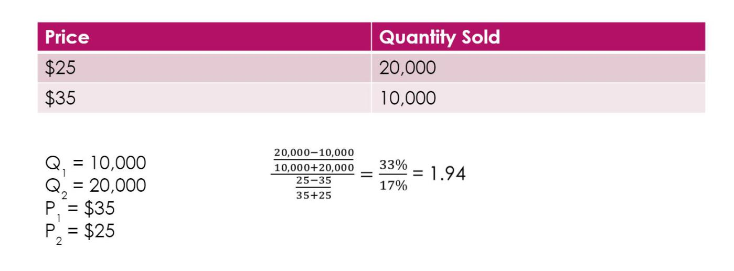

What does this mean?  If we raise the price by 1%, we can expect to sell roughly 2% fewer tickets, and conversely, if we lower the price by 1%, we can expect to sell roughly 2% more tickets.

## Demand Variations

Let’s graph the variations of quantity to price and quantity to revenue.  Being able to see it graphically, will allow you to understand Price elasticity more clearly.  Notice that the Elasticity changes as the range of prices change. The price elasticity coefficient of demand applies only to a specific range of prices.  Notice how when the quantity increases and the revenue increases, the demand is elastic. This follows with the definitions earlier in this lecture.

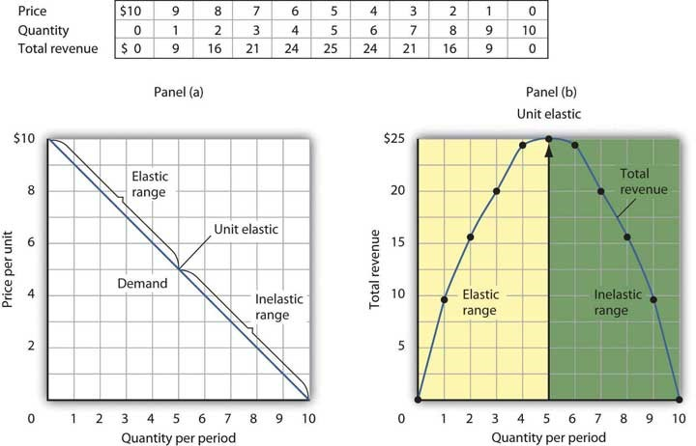

## Determinants of Price Elasticity

There are 3 determinants in the Price Elasticity of Demand

**Availability of Substitutes**

**Share of Budget Spent on the Product**

**Adjustment to a Price Change over Time**

**Availability of Substitutes** is by far the more important determinant included in price elasticity of demand.  Demand is more elastic, when a product has substitutes. For example, if car prices rise, consumers can switch to using buses.

**Share of budget spent on the product** means when the price of salt changes, consumers don’t really notice.  It is a minute part of a budget. But if the cost of college tuition increases, then people will start looking for alternatives.

**Adjustment to a price change over time** means people can respond to price changes over time.  Take gasoline for example. If price rises, in the short term, not much changes, but as time goes on and the price remains high, drivers will start to find alternatives.

It is interesting to see how price has an effect on the demand and total revenue of a product.

## Short Run Cost Formulas

In order to make production decisions in either the short or long run, a business has to determine the costs associated with producing the levels of output.  We have to study the relationship between short-run costs and output. We will use the total cost curves and the average costs curves. First, we’ll discuss the Total Cost curve.  Costs are divided between **two categories – total fixed cost and total variable cost.** **Total Fixed Cost (TFC) consists of costs that do not vary as output varied and must be paid even if output is zero.**  For example, even if a firm produces nothing, it must pay rent, property taxes, insurance, etc.

As firms expand from zero output, total variable cost is added to the total fixed cost.  **The Total Variable Cost (TVC) consists of costs that are zero when output is zero and vary as output varies.**  These costs relate to the costs of variable inputs. Examples are wages for hourly workers, fuel, and raw materials.  Variable costs can be controlled by management in the short run by changing the level of output.

**Lastly, the Total Cost (TC) is Total Fixed Cost + Total Variable Costs.**

In the example Short run cost schedule, note how the Fixed Cost remains unchanged and the Variable cost changed as the product increases from 0 to 1.  Let’s add to this chart and discuss Average Costs.

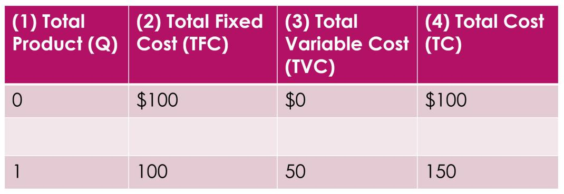

Firms are not only interested in total cost, they are also interested in average cost or a per unit cost.  Dividing the Fixed, Variable, and Total Costs by the quantity of output produced will yield the Average Fixed, Average Variable and Average Total costs.  The Average Total Cost can also be computed as Average Fixed Cost + Average Variable costs. Note how these formulas are similar to the Total Fixed, Total Variable, and Total Costs but are on a per unit basis.

Let’s add these average costs to our chart.  Let’s use the total product of 2 as an example.  The Average fixed cost is $50 which is the Total Fixed Cost of $100 divided by the quantity of 2.  Same with the Average variable Cost of $42. It is the TVC of $84 divided by the quantity of 2 the Average total costs is the sum of the Average fixed cost plus the Average variable cost, $50 + $42 = $92.

**Marginal analysis asks us how much it costs to produce one more unit.** The change in TC is divided by the change in quantity. The change in quantity from 1 produced to 2 produced is 1 or 2-1. The change in Total cost is 184-150 or $34.  $34 divided by 1 = $34. The Marginal cost between producing 1 and 2 units is $34.

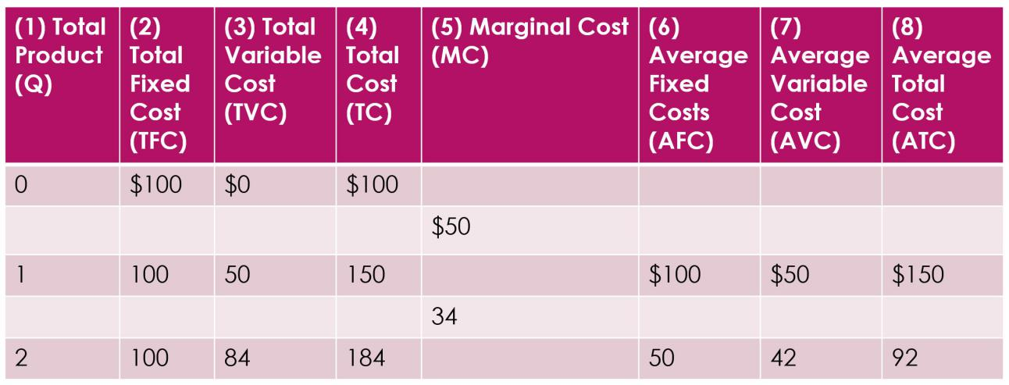

## Long-Run Production Costs

Now that we’ve learned Short-Run production costs, let’s move toward Long-Run production costs.  As we explained earlier, the long run is a time period long enough to change the quantity of all fixed inputs.  For example, a firm can build a larger or smaller factory. We will discuss how varying factory size and all other inputs in the long run affects the relationship between production and costs.

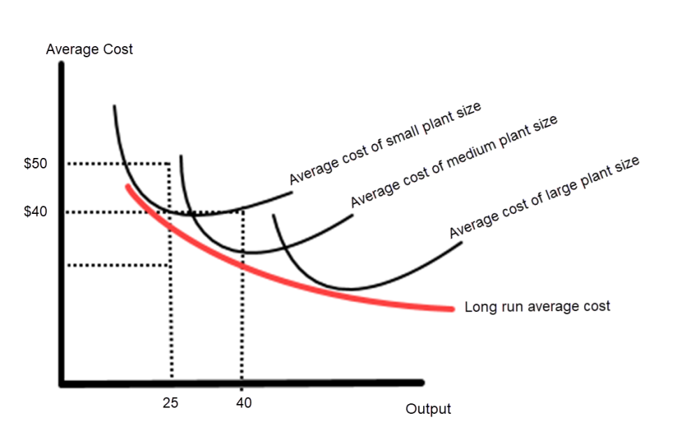

In the long run firms aren’t locked into say a factory size.  But once a factory is built, then firm operates in the short run, because the plant becomes a fixed input.  A firm operates in the short run when there is insufficient time to alter some fixed input. The firm plans in the long run when all inputs are variable.  The Black curves are the average total costs of the plant sizes in the short run or the SRATC – Short-Run Average total costs. The red curve is the Long run average cost  curve or LRAC. This LRAC is constructed from the 3 Short Run Average Cost Curves and formulates a curve around the lowest cost points.

## Different Scales of Production

Economies of scale exist when the long-run average cost curve declines as the firm increases output.  An example is an assembly line, when some workers specialize in one task. Economies of scale also result in better efficiency of capital.  If the LRAC does not change as the firm's output increases, that is called Constant Return to scale and if the curve rises, that is called Diseconomies of scale.  The cost begins to rise as the firm’s output increases.

## Price Taker

Let’s assume we have a firm that is operating in a perfectly competitive market.  The firm is a price taker. **A price taker is a seller that has no control over the price of the product it sells.**  *The price of its products is determined by market supply and demand conditions.* The firm has no influence on those conditions.  If we look again at the characteristics, it is impossible for the perfectly competitive firm to affect market price. Instead the firm has to adjust to or “take” the market price.

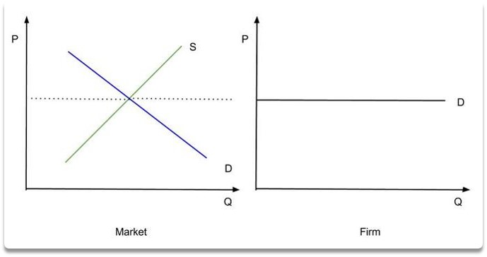

 The Market graph shows the market equilibrium price, the dashed line where the supply and demand curve intersect.  The perfectly competitive firm has to take that price and its demand curve is horizontal. The demand curve is perfectly elastic.  If the firm raises its price by even one cent, it will sell zero product. Remember this from previous modules. The firm will also not lower its price because that would lower the firm’s revenue and the firm can sell all it wants to at the going rate.

Since the firm has no control over price, it only makes one decision.  That decision is the quantity of output to produce to maximize profit. We will develop two profit-maximization methods.  First, the Total Revenue - Total Cost Method and then the Marginal Revenue equals Marginal Cost Method.

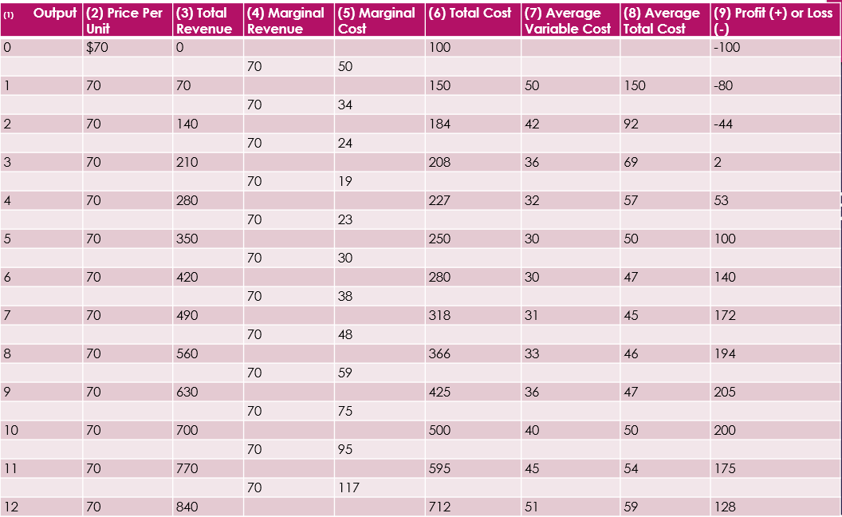

Total Revenue – Total Cost Method.  **The Total Revenue is the price per unit multiplied by the Unit Output.**  In this example the Unit Price is 70, so at an output of 2 units the total revenue is $70 x 2 which equals $140 reported in Column 3.  The Total cost in column 6 for 2 units is $184. Subtracting the total cost from the total revenue yields 140-184, a loss of $44. From 0 to 2 units, the firm is incurring a loss.  There is a break-even point (zero economic profit) around 3 units. At zero economic profit, the firm earns only normal profit, which is the minimum profit necessary to stay in operation.  If the firm produces 9 units, it earns the maximum profit.

## Marginal Revenue = Marginal Cost

Our second approach is the Marginal Revenue equals Marginal Cost.   This method uses marginal analysis to determine the profit-maximizing level of output by comparing the marginal revenue (or marginal benefit) and marginal cost.  **Remember when we say marginal, we’re speaking of the incremental changes of one unit.** *These marginal changes are listed in between the output lines in the chart because the marginal costs occur between each additional whole unit rather than exactly at the listed output level.*

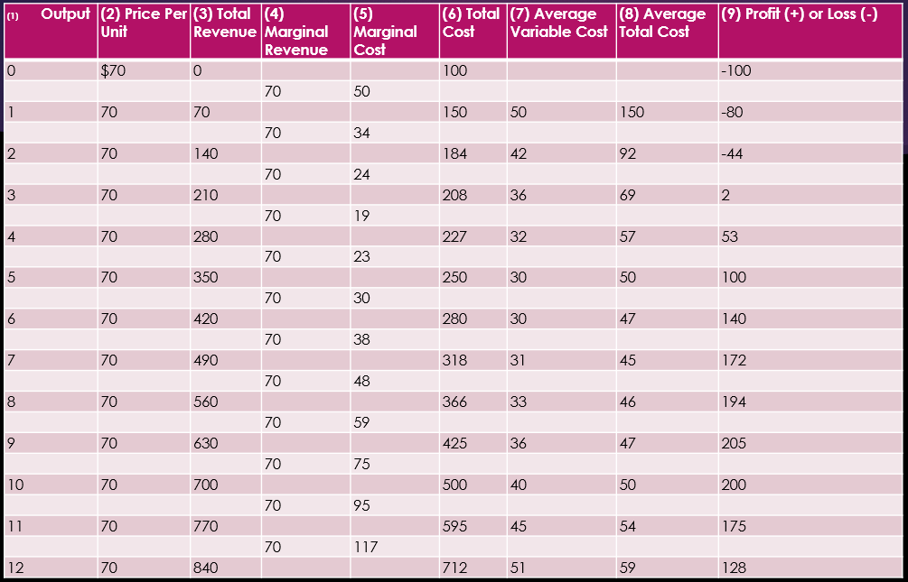

Now, what is marginal revenue? Marginal revenue is similar to marginal cost.  **Marginal revenue is the change in total revenue from the sale of one additional unit of output. Marginal Revenue is the ratio of the change in total revenue to the change in output.**  In our example, $70 is added to total revenue, each time a unit is sold. $70 is the marginal revenue for each additional unit of output, shown in column 4. We know the Marginal Revenue but how do we calculate the marginal cost?  We learned earlier that the marginal costs are the difference between the total costs when incrementing one unit. We will compare the marginal revenue and marginal cost as shown in columns 4 and 5. When using the Marginal Revenue equals Marginal Cost rule, the firm maximizes profit by producing the output where marginal revenue equals marginal cost.  This happens at approximately 9 units. Note how we arrived at the same profit maximizing conclusion using either method.

## Monopoly Market Structure

Next we will talk about Monopolies and not the game.  Although, playing the board game monopoly teaches some of the characteristics of monopoly theory that we will learn in the module.  In the game, players win by gaining as much economic power as possible. You want to own railroads, utilities, properties etc. Then you try to bankrupt your opponent by purchasing hotels that afford you to charge higher prices.  If a player lands on your property, they either have to pay or lose the game. Previously, we studied perfect competition, in which there were many sellers in the market, and each one lacked power to influence the price. The exact opposite is true in a monopoly.  Monopoly is of Greek origins meaning single seller. A monopoly has the market power to set the price and not worry about competition.

**A monopoly is a market structure characterized by (1) a single seller, (2) a unique product, and (3) impossible entry into the market.**  Unlike perfect competition, there are no close substitutes to the monopolist’s product.

Let’s examine the 3 characteristics of a monopoly.

* **Single Seller.** One firm provides the total supply of a product in a given market.  Local monopolies are more common real-world approximations. For example, there might only be one company that provides electricity.  Because there are no other competitors in the market, the firm can set the price and customers are forced to either pay or do without electricity.  Nationally, the U.S. Postal service monopolizes first class mail.
* **Unique Product.**  A unique product means that there are no close substitutes.  Thus there is little or no competition.
* **Impossible Entry.**  In a monopoly extremely high barriers make it difficult for new firms to enter the market.  A market that is easy to enter has no barriers to entry. A barrier to entry is any obstacle that makes it difficult for a new firm to enter a market.  Barriers can be financial, technical, or even government imposed. Licenses, permits, and patents are all barriers to entry. Resources must be completely mobile to freely enter or exit a market.

We will discuss 3 major barriers preventing new firms from entering a market.

1. Ownership of Vital Resource.  Sole control of the entire supply of an input is one way a monopolist can prevent newcomer entry into a market.  For example, today it is hard for a new sport’s league to enter the market to compete with the NBA or NFL. They already have contracts with the best players and signed contracts on the best stadiums and arenas.
2. Legal Barriers.  Government granted licenses prevent or restrict entry into some industries.  For example, water and sewer service, natural gas, and cable television operate under monopoly franchises that are established by state and local governments.
3. Economies of Scale. This means that a monopoly can occur naturally because of the relationship between average cost and the sale of an operation.  As a firm becomes larger, its per unit cost is lower compared to a smaller competitor. A new firm cannot enter the industry, because it cannot compete with the monopolist price.   This natural monopoly is an industry in which the long-run average cost of production declines throughout the entire market. As a result, a single firm can supply the entire market demand at a lower cost than two or more smaller firms.

Economies of scale and monopoly power can exist because consumers choose a product that everyone else is using.  A network good is a good that increases in value to each user as the total number of users increases. For example, people post to facebook to belong to the same network as others.  The greater the number of people connected to a network goods system, the more benefits of the product to each person are increased. Facebook would be useless with only 2 people. The more people on facebook, the more valuable it is.

## Natural Monopoly

As we explained before, a natural monopoly is an industry in which the long-run average cost of production declines throughout the entire market.  Therefore, a single firm can supply the entire market demand at a lower cost than two or more smaller firms. Network goods can result in a firm increasing sales rapidly thus achieving economies of scale.  Smaller firms have higher-cost products that cannot compete, and they in turn go out of business.

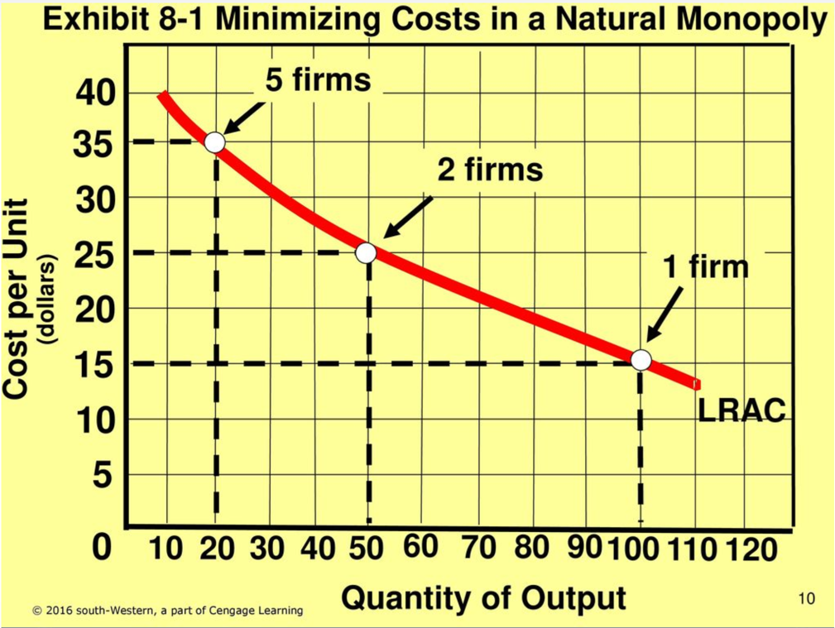

In the chart shown, a single firm produces at a lower cost than two or more firms.  This happens because the LRAC (Long Run Average Cost) curve decreases over the relevant range.  In this example, one firm can produce 100 units at an average cost of $15, total cost of $1,500.  Two firms can produce 100 units (50 units each) for a total cost of $2500, and five firms can produce the same 100 units total for a total cost of $3,500.  As you can see, the single firm can produce at a lower cost.

## Price Makers

A major difference between perfect competition and monopoly is the shape of the demand curve, not the shape of the cost curves.  Previously, we explained that a perfectly competitive firm is a price taker. But in this module, we will learn that a monopolist is a **price maker**.

**A price maker is a firm that faces a downward-sloping demand curve.**  *This means a monopolist can select the product’s price.* A monopolist can set the price with its corresponding level of output, rather than being forced and have no choice but to go with the going industry price.  In perfect competition, remember the curve is horizontal. Let’s use the marginal approach, like we have before and see how this works for monopolies.

## Profit Maximization for a Monopoly

The chart adds cost data to the demand, total revenue and marginal revenue data that we examined previously.  We will maximize profit using the total revenue minus total cost method. Subtracting Total Cost (column 6) from Total Revenue (column 3) yield the Total Profit or Loss as shown in Column 8 that the firm earns at each level of output.  The monopolist, Computech, incurs losses at output 0 to 1 unit. The breakeven point occurs before 2 units per hour. At 5 units, Computech earns the maximum profit of $190 per hour. Between units 5 and 8 of output, the profit diminishes.  After 8 units, there’s a second break even point and then the losses increase as output per hour increases.

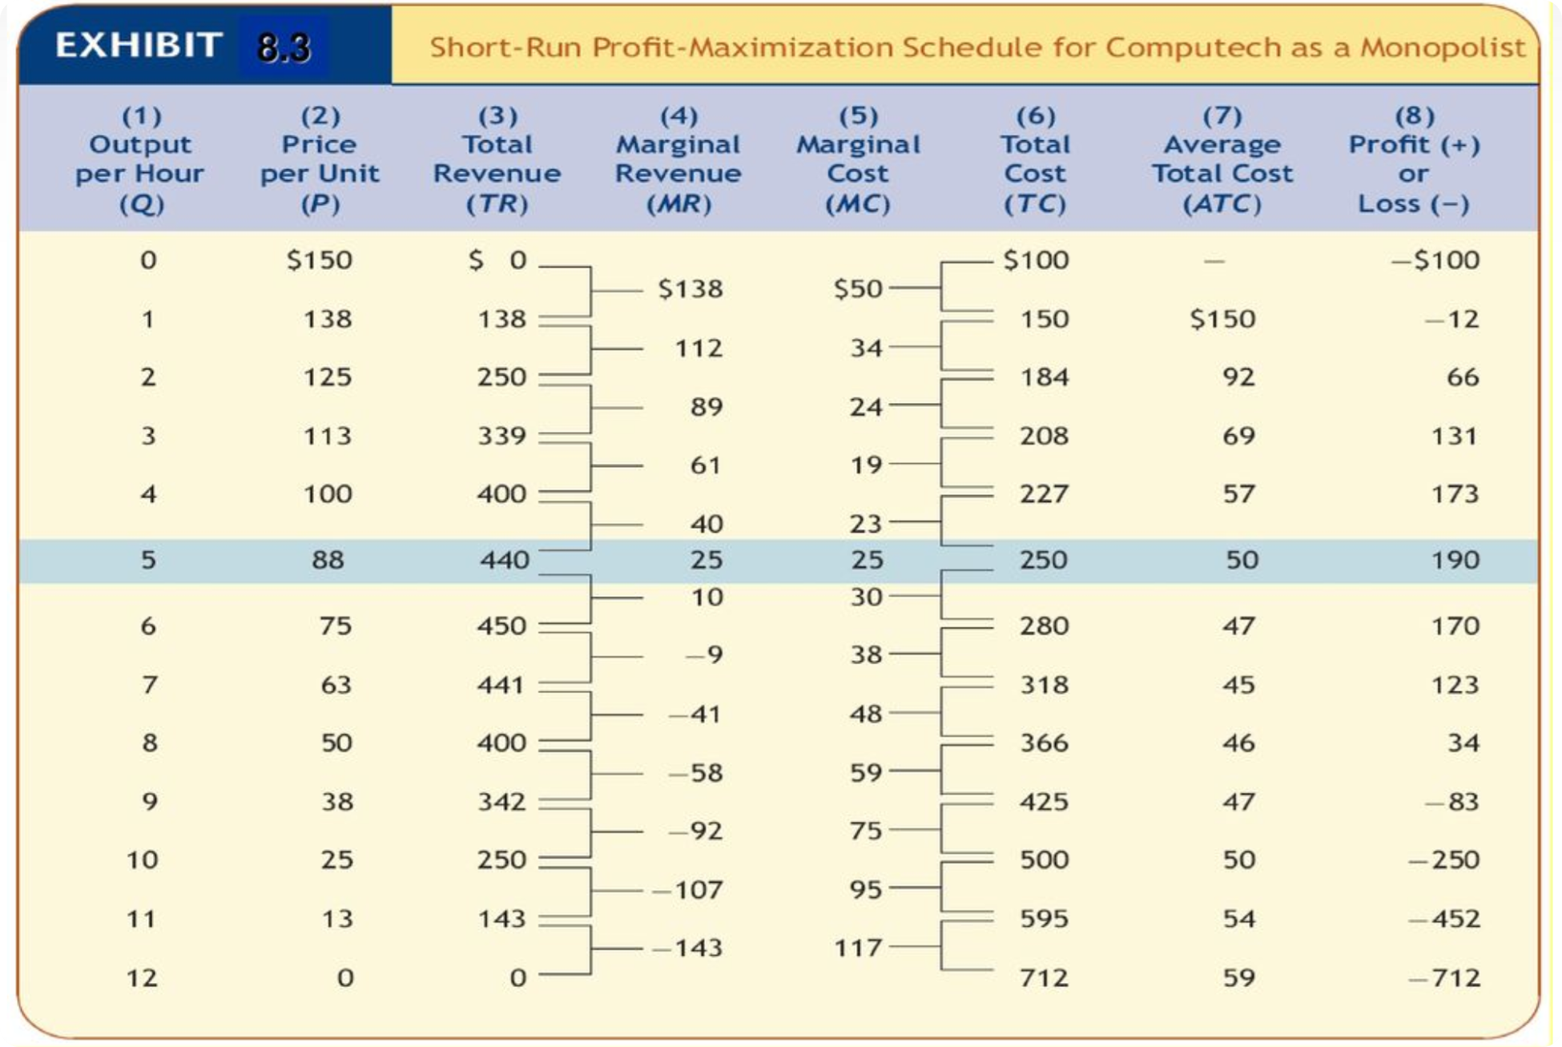

We can also view this graphically, in the graph (a) Total revenue and total cost.  The profit-maximizing output is where there is the greatest distance between the total cost and total revenue curves, 5 units output per hour, profit of $190.

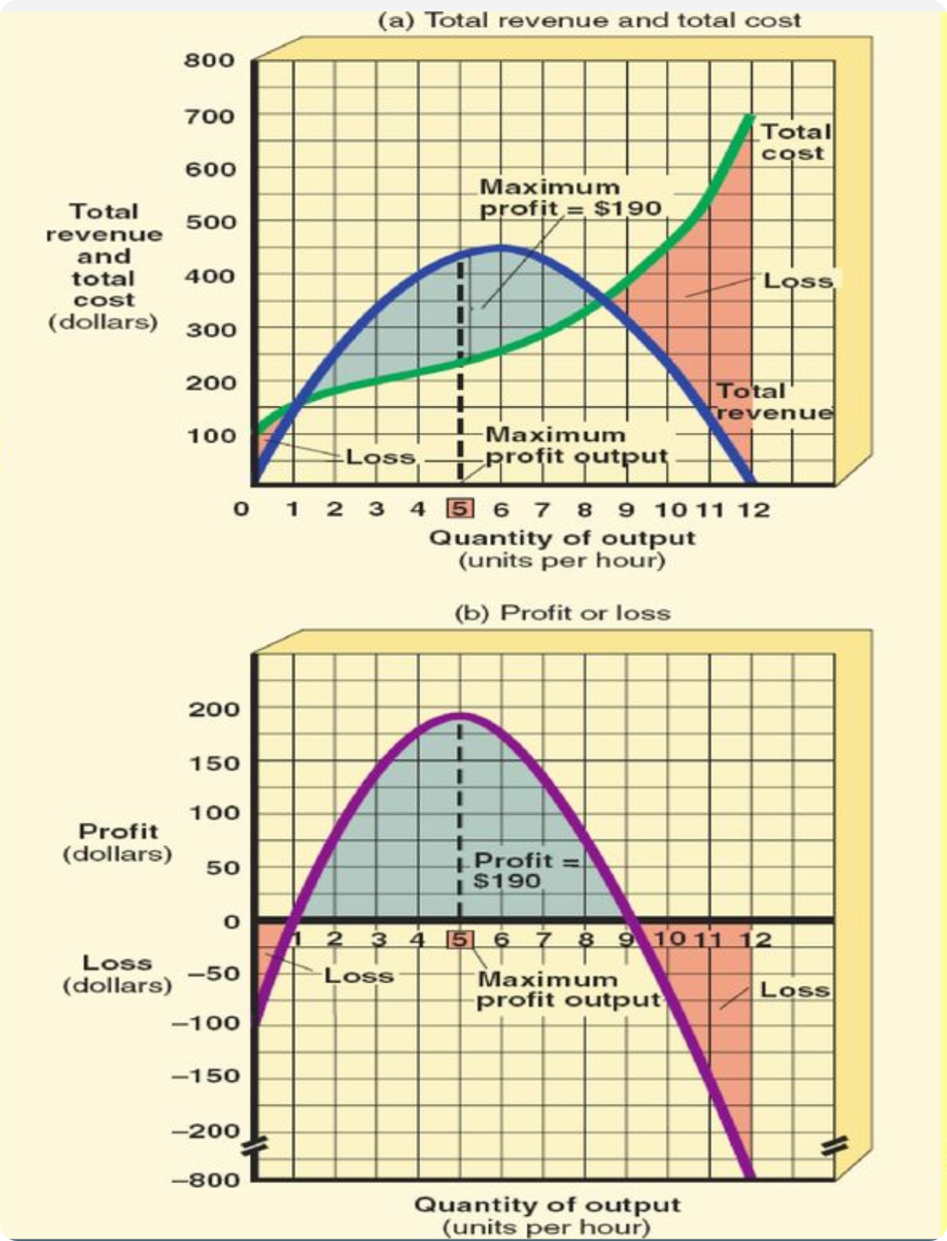

Now, we will show profit maximization using the marginal revenue equals marginal cost method.  The graphs (a) and (b) show demand and cost curves of the numeric exhibit. Similar to the perfectly competitive firm, a monopolist maximizes profit by producing the quantity of output where MR = MC, Marginal Revenue equals Marginal Cost, and charging the corresponding price on its demand curve.  In this example, 5 units is where the marginal revenue equals marginal cost. As shown on graph (a), this is point A on the demand curve (the blue line). The price at 5 units per hour output is $88. In graph (b), at 5 units, you can see that is where the profit is maximized. Note at output levels below 2 or above 10, losses are incurred.

## Short Run Loss for a Monopoly

Just because you have a monopoly, it does not guarantee profit.  A monopolist does not have any protection against changes in demand or cost conditions.  *This is a situation in which the demand curve is lower at any point in the ATC (Average Total Cost) curve and hence total cost exceeds total revenue at any price charged.*

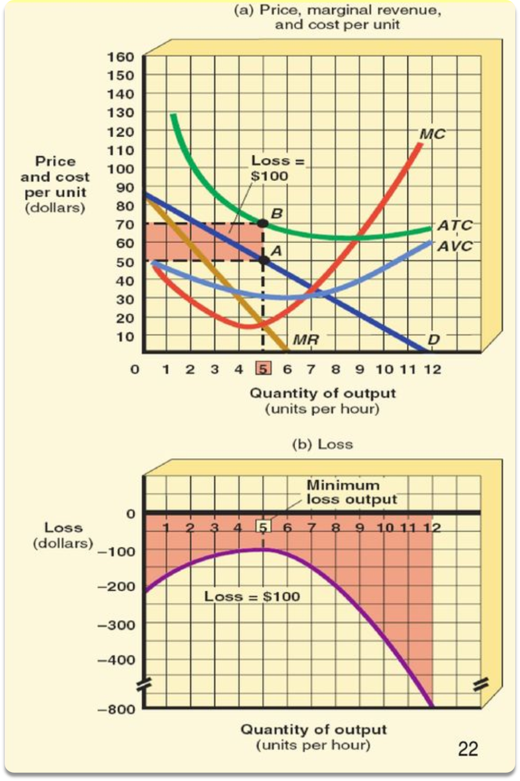

At point A in graph (a) where the MR = MC at a price of $50 on the demand curve (blue line) is about the AVC curve (light blue line), but below the ATC (green line) curve, the best Computech, our fictional monopolist, can do is minimize the loss.  So, just like the perfectly competitive firm, the monopolist will produce in the short run where MR = MC, a quantity of 5 units output per hour. 5 units at a price of $50, point A, the ATC (Average Total Cost) point B is $70. Computech will incur a loss of $100.  Cost – Price, 70-50, is $20 loss per unit. $20 times 5 equals a loss of $100. You can also see that in graph (b) of the loss at 5 units. What if MR=MC is at a price **below** the AVC (Average Variable Cost)?  Well, then just like in perfect competition, the monopolist will shut down. To continue operations would only add to the losses.

## Monopoly in the Long Run

In perfect competition, economic profits are impossible in the long run.  The entry of new firms into the market drives the product price down until profits reach zero.  But because of high barriers to entry, monopolists are insulated so to speak. If the positions of a monopolist’s demand and cost curves give it a profit and nothing disturbs these curves, the monopolist will earn a profit in the long run.  The monopolist has flexibility in the long run. Just like a perfectly competitive firm, the monopolist can change plant size to lower costs. But if losses persist, monopolistic firms will not remain in business in the long run. It will transfer its resources to a more profitable industry.  Barriers of entry will not protect monopolists from competition in the long run. One threat is that entrepreneurs will find innovative ways to compete. For example, with Computech, if a rival produces a similar product, Computech might sacrifice short run profits to earn greater profits in the long run.  It might charge a price below $88 and produce an output greater than 5 units per hour.

## Monopolistic Competition Market Structure

**Monopolistic competition is a market structure characterized by (1) many small sellers, (2) a differential product and (3) easy market entry and exit.**

**Many small sellers**: Under monopolistic competition, the exact number of firms cannot be stated, but the number of sellers is smaller than in the perfect competition market structure.  Consumers have many different varieties of products to choose from and the prices are competitive. No single seller has a large enough share of the market to control prices. Many sellers' conditions are met when each firm is so small relative to the total market that its pricing decisions have a negligible effect on the market price.

**Differentiate Product:** This is a key feature of monopolistic competition.  Product differentiation is the process of creating real or apparent differences between goods and services.  A differentiated product has close, but not perfect, substitutes. Although the products of each firm are highly similar, the consumer views them as different.  In our example, there may be 15 other seafood restaurants in town. But they differ in location, atmosphere, quality of food, service, and so on. Product differentiation can be real or imagined.  It doesn’t matter, as long as consumers believe differences exist. When a product is differentiated, buyers are not indifferent as to which seller’s product they buy. With the Mama’s Fried Fish example, rivalry under monopolistic competition centers on nonprice competition in addition to price competition.  Non-price competition is a situation in which a firm competes using advertising, packaging, product development, better quality, and better service rather than lower price. It is an important characteristic of monopolistic competition that distinguishes it from perfect competition and monopoly. A monopolist has no incentive to engage in non-price competition because it sells a unique product.

**Easy Market Entry and Exit**: Firms in a monopolistically competitive market face low barriers to entry.  But entry isn’t as easy as in perfect competitive markets. People who want to enter the seafood restaurant market can get loans, lease space and start serving without much trouble.  But they might have difficulty attracting customers because Mama’s Pasta already has an established reputation.

Monopolistic Competition is the most common market structure in the United States.

And lastly, the monopolistic competitive firm is a price maker.  The primary reason is because its product is differentiated. Like the monopolist, it has some limited control over its price.  The demand curve for a monopolistically competitive firm is less elastic (steeper) than for a perfectly competitive firm and more elastic (flatter) than for a monopolist.

## Comparing Monopolistic Competition and Perfect Competition

Some economists argue that long-run equilibrium conditions for a monopolistically competitive firm as shown in this graph for long-run, results in poor economic performance.  Others contend that the benefits of a monopolistically competitive industry outweigh the costs. Let’s try to understand both sides of this debate.

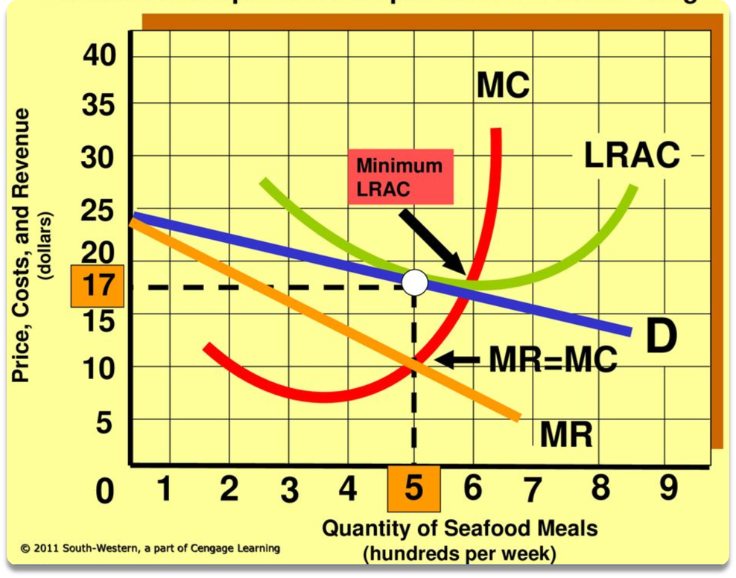

This is the Monopolistic Competitor as a Resource Misallocator. The monopolistic competitive firm fails the efficiency test, same as monopolist.  Shown in this graph. Mama’s Fried Fish restaurant is charging a price that exceeds the marginal cost (red curve). The value to the consumers of the last meal produced is greater than the cost of producing it.  Mama could devote more resources and produce more meals. But in order to sell additional output, Mama would need to move downward along the demand curve (blue line) and have to lower the price of each meal. Customers would purchase the additional benefits of consuming more meals. But Mama’s uses less resources and restricts output to 500 meals a week in order to maximize profits where MR = MC.

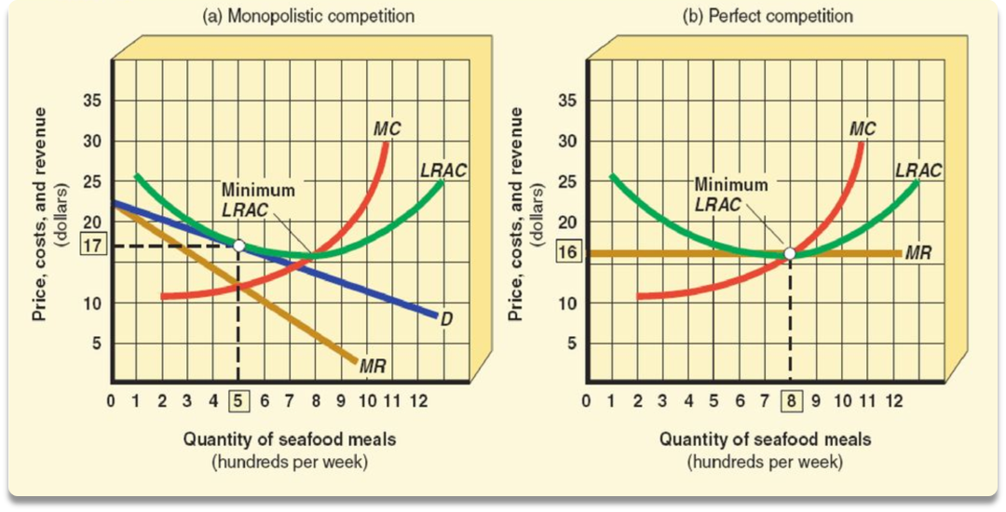

Monopolistic competition means less output for more.  Graph (a) shows the long run conditions from before and graph (b) assumes that Mama’s fried Fish is perfectly competitive.  We assume that the seafood meals are homogenous and that no advertising is needed among firms, and that Mama’s product is identical to all other seafood restaurants.  Mama’s Fried Fish becomes a price taker. In the Perfect competition assumption, the Long Run supply and demand curves set an equilibrium price of $16 per meal. Mama’s will have a horizontal demand curve with the price equal to marginal revenue. Long-run equilibrium for a perfectly competitive firm is established by the entry of new firms until the minimum point of $16 per meal on the firm's LRAC curve equals the price, MR and MC as stated in this formula P = MR =MC = LRAC.

Comparing the two graphs (a) and (b) reveals two points.  1) both monopolistic and perfect competition earn zero economic profit in the long run and 2) the long-run equilibrium output of the monopolistically competitive firm is to the left of the minimum point on the LRAC curve and the price exceeds MC.  Therefore, the monopolistically competitive firm charges a higher price and produces less output than a perfectly competitive firm.

In this example, as shown, Mama would charge $1 less per meal and produce 300 more meals a week in a perfectly competitive market.  The extra 300 meals not produced are excess capacity, which represents underutilized resources. The criticism of monopolistic competition, is that there are too many firms producing too little output at inflated prices and wasting resources in the process.  In the restaurant example, there are not enough customers for all the restaurants in town. Staff, tables, and other resources are underutilized. With fewer firms, each could produce a greater output at a lower price and with a lower average cost.

But on the contrary, having many seafood restaurants gives consumers more choice and variety.  It forces competitors to give extra quality and service.

## Evaluation of Oligopoly

Oligopoly is more difficult to evaluate than the other market structures.  Depending on assumptions made, an oligopolist can behave like a perfectly competitive firm or more like a monopoly.  Let’s describe the likely changes that occur is a perfectly competitive industry is suddenly turned into an oligopoly selling a differentiated product.

* 1. Price charged for the product will be higher than under perfect competition.  The smaller the number of firms and the more difficult it is to enter the industry, the higher the oligopoly price will be in comparison to the perfectly competitive price.
  2. An oligopoly is likely to spend money on advertising, product differentiation, and other forms of nonprice competition. These expenditures can shift the demand curve to the right.  Both price and output may be higher under oligopoly than under perfect competition.
  3. In the long run, a perfectly competitive firm earns zero economic profit.  The oligopolist can earn a higher profit because it is more difficult for competitors to enter the industry.

## Review of Market Structures

Here is a brief review of the four market structures that we have learned about. This chart summarizes the characteristics and gives examples.

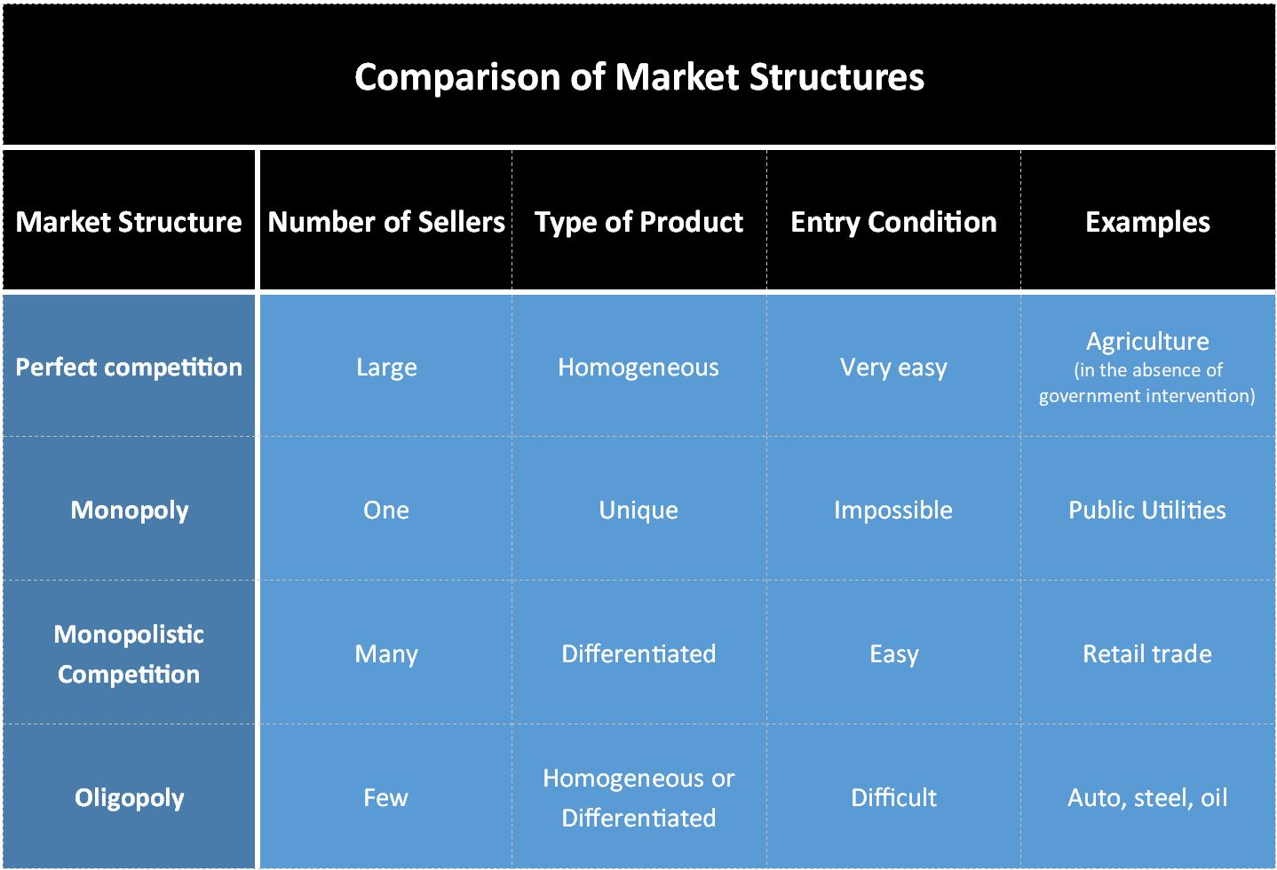

## Labor Market Under Perfect Competition

In previous modules, we studied price and quantity determinations of goods and services produced by firms operating under different market structures – perfect competition, monopoly, oligopoly, and monopolistic competition.  Just like market structure affects the price and quantity of goods or services sold by firms to consumers, we will go on to study how the price paid to labor and the quantity of labor hired by firms are influenced by whether or not the labor market is competitive.  We will further study the hypothetical firm Computech. We’re going to assume that Computech is hiring workers in a perfectly competitive labor market. In this market, there are many sellers and buyers of labor services. Wages and salaries are determined by the intersection of the demand for labor and the supply of labor.

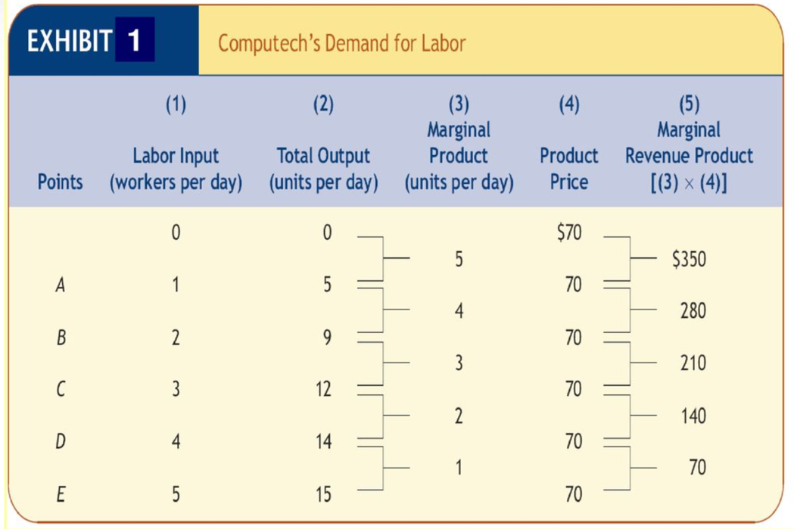

How many workers should Computech hire?  In order to answer that, Computech must know how much workers contribute to its output.  In column 1, lists the possible number of workers Computech might hire per day. Column 2 is the total output per day.  1 worker would produce 5 units a day, 2 works would produce 9 units a day and so on and so forth. Column 3 gives the additional output for each additional worker hired.  Column 4 is the price per unit of product and then Column 5 gives the marginal revenue product (MRP) of each additional worker hired. This is the increase in a firm’s total revenue resulting from hiring an additional unit of labor or other variable resource.  MRP is the dollar value of worker productivity. For example hiring a second worker increases revenue by $280. Because the additional worker produced an additional 4 units of product. Multiply that 4 units by the price of $70 and you have $280 of MRP. A perfectly competitive firm’s marginal revenue product is equal to the marginal product of its labor times the price of its product. MRP = P x MP

## Equilibrium Wage Rate

**Wage rates are determined in perfectly competitive markets by the interaction of labor supply and demand.**  The equilibrium wage rate for the entire Electronic components market is $210 as shown in Exhibit 4(a). The wage rate clears the market because the quantity demanded equals the quantity of 30,000 workers who are willing to supply their services at that wage rate.  In a competitive labor market, no single worker can set his wage above the equilibrium wage. A worker fears not being hired because there are so many workers who will work for $210 per day. Also, the same goes for firms. So many firms are hiring that a single firm cannot influence the wage by paying more or less than the prevailing wage.  So, a rate about $210 would create a surplus of workers seeking employment and a wage rate below would cause a shortage.

Why does a cardiologist make a higher wage than a restaurant server?  Wage differentials are determined by the demand and supply curves in labor markets for these occupations. The equilibrium wage rate for cardiologists greatly exceeds the equilibrium wage rate for servers.

The supply curve of labor is upward sloping for the market, but that’s not the case for the individual firm.  As shown in exhibit 4(b), the supply curve is horizontal for Computech. Remember a competitive labor market assumes that each firm is too small to influence the wage rate, so Computech is a wage taker and pays the market determined wage of $210 per day.  It will then hire labor up to the Equilibrium point E where the wage rate equals the third worker’s marginal revenue product.

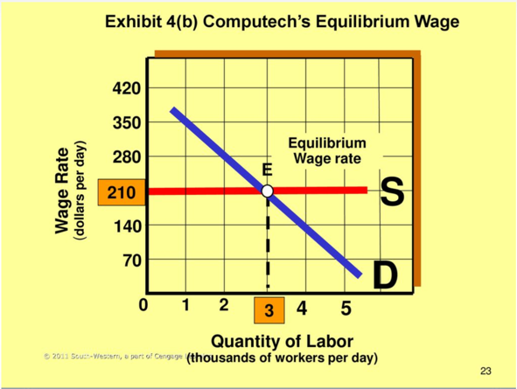

## Unions Around the World

How important are unions as measured by the percentage of the labor force that belongs to a union?  During the Great Depression, millions of people were out of work and union membership was relatively low.  To boost employment and earnings, Franklin Roosevelt’s National Industrial Recovery Act (NIRA) of 1933 established the right of employees to bargain collectively with their employers, but the act was declared unconstitutional by the Supreme Court in 1935.  However, the 1935 National Labor Relations Act (NLRA), also known as the Wagner Act, incorporated the labor provisions of the NIRA. The impact of this legislation and the production demands of World War II caused union membership to soar.

Although since WWII, union power has declined.  Membership has fallen from about 35% of the labor force in 1945 to roughly 12% today.

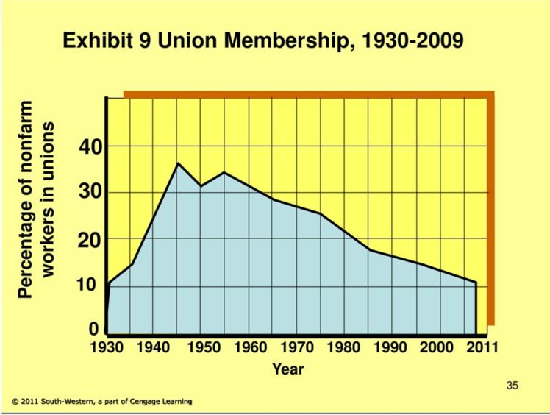

This image shows the unionization rates in other countries.  Union membership in the US is far below that of other industrialized countries.

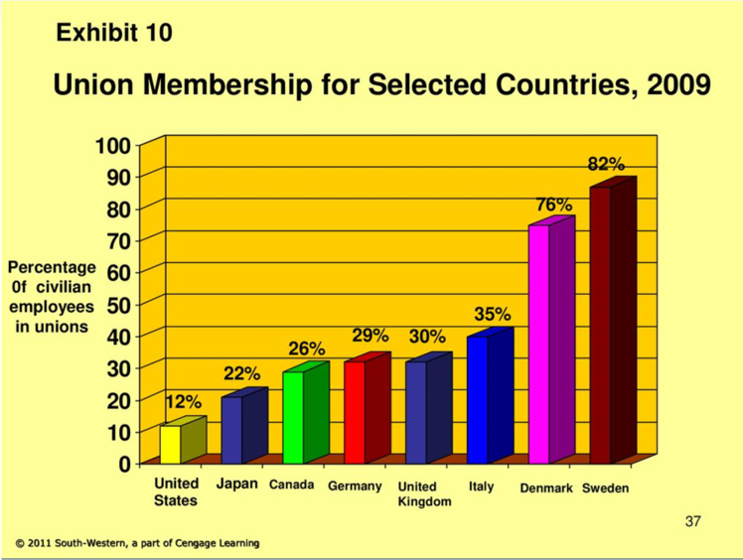

## Equality vs Efficiency

The normative question to be debated concerns the pros and cons of a more equal income distribution.  Those who favor greater equality fear the link between the rich and political power. The wealthy may use their money to influence national policies that benefit the rich.  It is also argued that income inequality results in unequal opportunities for various groups. For example, children of the poor have difficulty obtaining a college education.  Their underutilized productive capacity is a waste of human capital. The poor are also unable to afford health care, and this is a national concern.

Advocates of income inequality pose this question:  Suppose you have a choice of living in egalitarian society A, where every person earns $40,000 a year or society B, where 20% earn $100,000 and 80% earn $30,000.  You would likely choose society B because the incentive to earn more and live better is worth the risk of earning less and living worse. After all, why is the average income higher in society B?  Income inequality gives people an incentive to be productive. People in society A lack motivation to work hard because everyone is earning the same income.

This graph traces real median family income, adjusting for rising prices. The general trend for median income has been upward.  Simply observing changes over time doesn’t tell the whole story. The size of the pie grew, but some of the slices grew larger than others as shown in the distribution by percentage of families.

